**Crypto for Dummies: using interactive data-technology to kickstart crypto-investing**

April 29, 2022

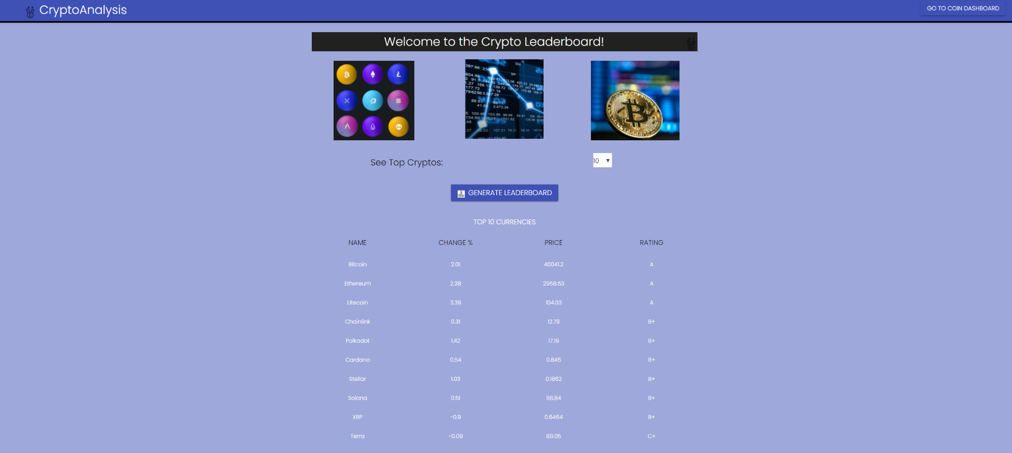

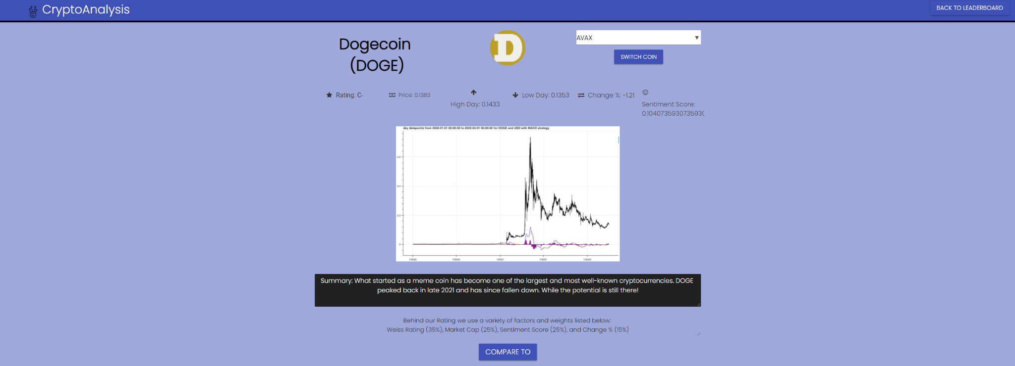

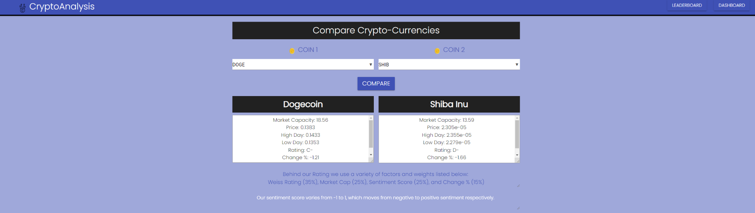

43,509. That’s the amount of money that we, as a team, have lost in our crypto-investing endeavors till date. It also happens to be equivalent to a semester's worth of tuition for non-residents at Cal. But we’re not the only ones. We spoke to many of our peers, and friends to find out that either they have lost a lot of money in the crypto-currency market and have stopped investing in it, or are not sure how to begin investing in it. 90% of the general population don’t know that the Bitcoin supply is capped, and 98% don’t yet have a grasp of the general concepts behind crypto basics. One thing is clear: the crypto-market is new, upcoming, volatile and here to stay.

To solve this problem, we decided to build an application that would allow people to interactively learn about crypto-currencies and the general consensus about them. We market it as “Crypto for Dummies”, given the new nature of the crypto market and the fact that people are still learning about it. Our application is a web page that features crypto-currency ratings and data-analysis through news channels, and crypto websites. We also generate a “sentiment” score based on our analysis to give an idea of the general public sentiment (positive or negative) towards the cryptocurrency - because the crypto market is one that can be highly affected by this. Our application also lets users compare crypto-currencies, by looking at their graphs, previous high/low prices and sentiment scores.

Our goal is to help people make more informed investing decisions by giving them as many resources as possible. To help accomplish this, we need to differentiate ourselves from other resources currently available. One such resource is the Weiss rating, where they give cryptos a letter rating. The issue with this is that their rating system is very complicated and hidden from the consumers. They can only trust that they are being led to the right path. Crypto for Dummies, however, will show our rating equation for every coin. This is so potential investors will understand what is going into our grade, and whether that aligns with their strategy.

We have conducted entry level user testing where a potential investor would explore the app, and have received good feedback on how simple, easy to understand, and transparent our webpage is. Many would feel more comfortable using a resource like this compared to others that are currently available.

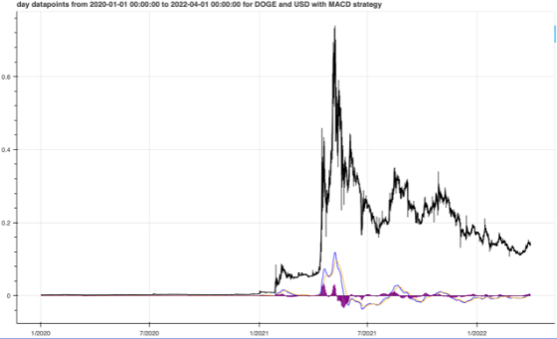

On the backend, generating the graph as well as the rating took quite a bit of time since we did some trial and error phase to see the distribution of the features we used to calculate the rating. We applied an ensemble method on three models (random forest, decision trees, and extra trees) to find the best model to calculate the rating. However, by the end of the semester, our team successfully constructed a transparent app that hopefully would be a helpful prototype for those who want to learn more about investing in crypto. Our next steps will be to increase the number of coins that the users can access in detail.

**Project by:** Daniel Tu, Lawrence Wang, Jonathan Lei, Tanya Krishan, Tiffany Natasha

**Mentor:** Ikhaq Sidhu and Derek S. Chan

**Live demo link:** <https://drive.google.com/file/d/1EFiTmnerL3kPYkD1pWSM_FbCkwHMbA4X/view?usp=sharing>